**TALAL**

**MAHMUD**

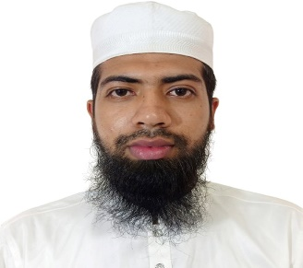

**SUMMARY**

**To** build my career as a software professional where I can show my skills and prove myself as an adaptive learner and highly qualified professional and help my skills and specializations. I always look for challenges where I can use my potential at most and always love to work in innovative technologies.

**EDUCATIONS**

**Bachelor of Computer Science and Engineering**

**2017-2022** Dhaka University of Engineering & Technology, Gazipur

CGPA- 2.87 out of 4.00

**Diploma in Electronics Technology**

**2012-2016** Dhaka Ploytechnic Institute

CGPA: 3.64 out of 4.00

**Secondary School Certificate**

**2011** Kohinur Boys High School

GPA: 4.81 out of 5.00

**PROJECTS**

**Project-1** **Todo App**

HTML, CSS, JavaScript, React

**Project-2**  **Student Management System**

HTML, CSS, JavaScript, Bootstrap, Django

**Project-3** **Customer Relational Model(CRM)**

HTML, CSS, JavaScript, Bootstrap, Django

**REFERENCES**

**Dr. Rafiqul Islam**

Professor

Department of Computer Science and Engineerin

Dhaka University of Engineering & Technology, Gazipur

**CONTACTS**

Chandona, Chowrasta, Gazipur

Phone: +88 01795257742

E-mail: [mahmudtalal2@gmail.com](mailto:mahmudtalal2@gmail.com)

**SKILLS**

* C++
* C#
* Python
* Django
* HTML
* CSS
* JavaScript
* React JS
* Bootstrap
* MySql
* PostgreSql

**LANGUAGES**

* Bangali – Mother Tongue
* English – Good Command over

reading, writing, listening and

speaking

**PERSONAL DETAILS**

Father: Taz Uddin

Mother: Aklima

Religion: Islam

Date of birth: 08-04-1994